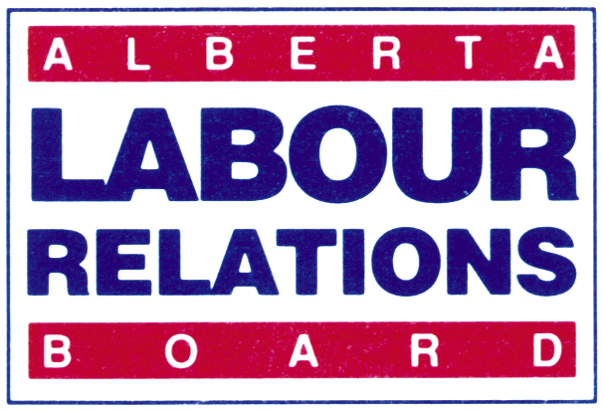 | APPLICATION FOR  CEASE AND DESIST ORDER  (URGENT MATTER)

- Please type or print clearly. Attach extra pages if necessary
- This is not a mandatory form.
- Should you send in a cease and desist application by letter, you should include the details presented on this form.
- Any personal information provided in this form is collected by the Labour Relations Board pursuant to section 4(c) of the Protection of Privacy Act (“POPA”) to process the application. Any further personal information received in connection with this application will be collected under that authority. The collection and use of personal information is managed pursuant to POPA. Disclosure of personal information is managed pursuant to POPA and the Access to Information Act. Please direct questions on the collection or use of personal information to the Board Officer assigned to your file, or to the Board’s Privacy Coordinator at 640, 10155 102 Street, Edmonton, AB, T5J 4G8, or (780) 422-5926.
- Please note that any relevant information provided to the Board must be provided to all affected parties to the application so they know the case to be heard and have an opportunity to respond.

APPLICANT INFORMATION

Name:

Mailing Address:
City: Province: Postal Code:

Business Telephone: Cell Phone: Fax No.:

Email Address:

Name of Contact Person:

Mailing Address (if different from above):

City: Province: Postal Code:

Business Telephone: Cell Phone: Fax No.:

Email:

RESPONDENT INFORMATION

Legal Name:

Mailing Address:
City: Province: Postal Code:

Business Telephone: Cell Phone: Fax No.:

Email Address: Website:

Name of Contact Person:

Mailing Address (if different from above):

City: Province: Postal Code:

Business Telephone: Cell Phone: Fax No.:

Email:

SECTION OF THE CODE/ACT ALLEGED TO BE BREACHED

What is the Section of the Code/act alleged to have been breached:

URGENT MATTERS

Describe the circumstances and consequences of the actions which leads the applicant to believe this is an urgent matter for the Board to deal with.

OTHER MATTERS/APPLICATIONS

Certificate Number (if applicable):
Date of expiry of the collective agreement:
Description of the bargaining unit:

Is there a dispute on-going between the parties? ______Yes _______No
If so, describe.

Are there other applications/complaints before the Board affecting these parties? ______Yes _______No
If so, describe. (Include Board file number):

DETAILS/PARTICULARS OF THE CONDUCT ALLEGED TO BREACH THE CODE
(Include specifics of each action complained of - who did it, when, where, who witnessed it, what was the impact of the action, how did it breach the Code.)

Are there documents, pictures, video or other record of the action? ______Yes _______No
Type of document (Identify for each action complained of):

Has this information/documentation been provided to the respondents? ______Yes _______No
When and how?

DETAILS OF DISCUSSIONS BETWEEN THE PARTIES
(Have the parties met and attempted to resolve the matter? When and who was present? List the issues resolved and those still outstanding.)

REMEDY SOUGHT
(Include specifics of the remedy sought against each respondent, including a draft order.)

How would an order best be served? In what format and to whom?

AVAILABILITY FOR HEARING
(List the dates and times that the applicant will be available for hearing and the number of witnesses expected.)

SIGNING

Signature: ________________________________________________________________________________________

Printed Name: ________________________________________________________________________________________
Position: ________________________________________________________________________________________

Date of Signing: ________________________________________________________________________________________

FOR BOARD USE ONLY:  Board File Number:  Checked by Received by Input by  □ Membership evidence and union  organizer's declaration received. |  | Complete and deliver to:  Alberta Labour Relations Board Alberta Labour Relations Board  #640, 10155 – 102 Street #308, 1212 31 Avenue, N.E.  Edmonton, AB T5J 4G8 Calgary, AB T2E 7S8  Phone: (780) 422-5926 Phone: (403) 297-4334  Fax: (780) 422 – 0970  Applications can be emailed to the Board at ALRB.EDM@gov.ab.ca  The Board does not require original applications.

